**Moving Car System Design**

Author: Mahmoud Saeed Mowafey.

Reviewers: Sprints.

Date: 05/04/2023

**Overview**

We have a four-diving wheel robot, and we want to design the system so that the car moves in a rectangular shape.

System design for this project in Sprint number 3.

**System Requirements**

1. **Car Components**:
   1. **Four** motors (**M1**, **M2**, **M3**, **M4**)
   2. **One** button to start (**PB1**)
   3. **One** button for stop (**PB2**)
   4. **Four** LEDs (**LED1**, **LED2**, **LED3**, **LED4**)
2. **System Requirements**:
   1. The car **starts initially**from **0 speed**
   2. When **PB1**is **pressed**, the car will **move forward after 1 second**
   3. The car will move forward to **create the longest side of the rectangle for 3 seconds with 50% of its maximum speed**
   4. After finishing the first longest side the car will **stop for 0.5 seconds**, **rotate 90 degrees to the right**, and **stop for 0.5 second**
   5. The car will move to **create the short side** of the rectangle at **30% of its speed for 2 seconds**
   6. After finishing the shortest side the car will stop for **0.5 seconds**, **rotate 90 degrees to the right**, and **stop for 0.5 second**
   7. Steps **3 to 6** will be **repeated infinitely** until you press the **stop button (PB2)**
   8. **PB2**acts as a **sudden break**, and it has the highest priority

**Layered architecture**

It divides the system into a set of layers, each of which has a specific responsibility and interacts with other layers in a well-defined way.

The **MCAL** which contains the microcontroller drivers.

The **ECUAL** which contains the connected electronics components that will use the microcontroller drivers.

The **APP** Layer that will contain code application that performs the desired functionalities.

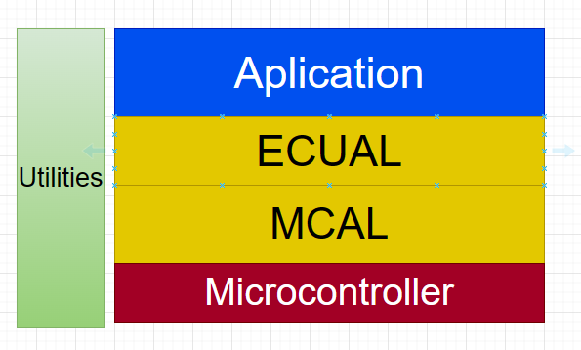

**Figure 1: System Layered Architecture**

**System modules/drivers**

It shows the different modules that will be used inside each layer.

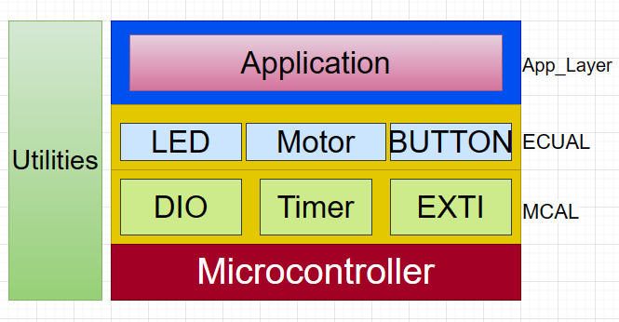

**Figure 2: System Modules for each layer**

**APIs for each module**

It defines the high level interface of each module/component.

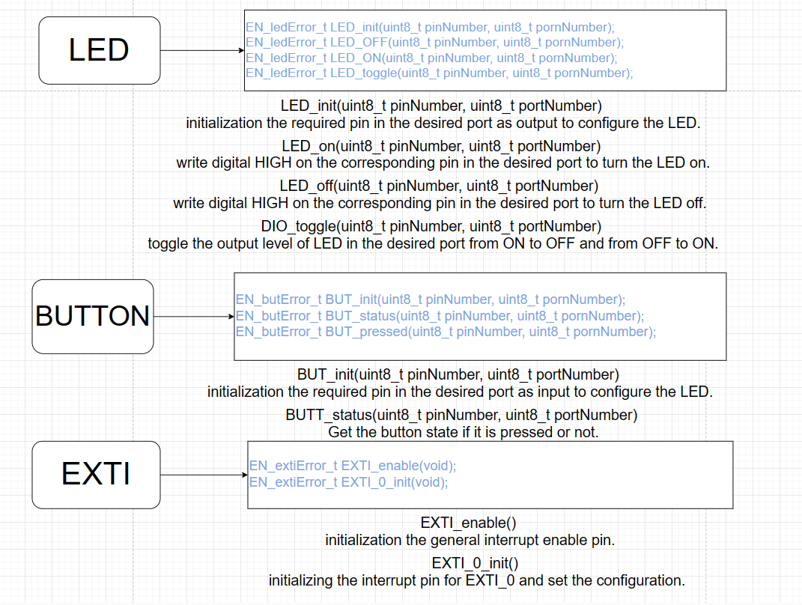

**Figure 3: APIs_with_documentation_1**

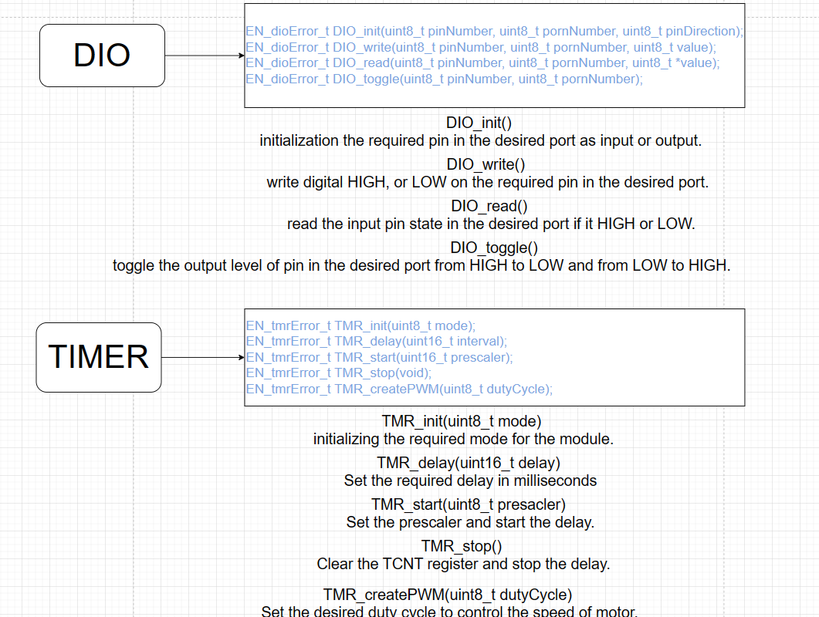

**Figure 4: APIs_with_documentation_2**

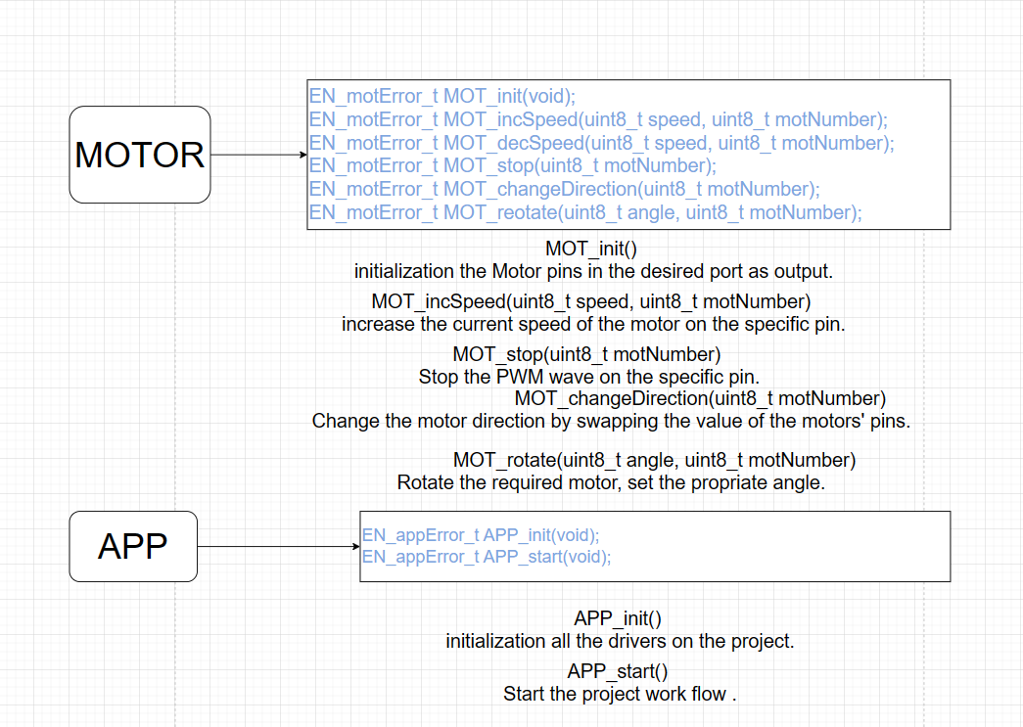

**Figure 5: APIs_with_documentation_3**